Exploring World’s Top Youtube Channel

1.INTRODUCTION

* YouTube is an online video sharing and social media platform headquartered in San Bruno, California, United States.
* Accessible worldwide,[7] it was launched on February 14, 2005, by Steve Chen, Chad Hurley, and Jawed Karim. It is owned by Google and is the second most visited website in the world, after Google Search.
* YouTube has more than 2.5 billion monthly users,[8] who collectively watch more than one billion hours of videos every day.[9] As of May 2019, videos were being uploaded to the platform at a rate of more than 500 hours of content per minute.[10][11]

1.1OVERVIEW

* A subscriber to a channel on the video-sharing YouTube is a user who has chosen to receive the channel's content by clicking on that channel's "Subscribe" button, and each user's subscription feed consists of videos published by channels to which the user is subscribed.
* The ability to subscribe to users was introduced in October 2005. YouTube began publishing a list of its most- subscribed channels in April 2006.
* An early archive of the list dates to May 2006.

1.2PURPOSE

* The following table lists the 50 most-subscribed YouTube channels, as well as the primary language and content category of each channel. The channels are ordered by number of subscribers.
* Those whose displayed subscriber counts are identical are listed so that the channel whose current growth rate indicates that its displayed subscriber count will exceed that of the other channel is listed first.
* Automatically generated channels that lack their own videos (such as Music and News) and channels that have been made effectively obsolete as a result of the transferal of their content (such as Justin Bieber VEVO and Taylor Swift VEVO) are exclude.

2.PROBLEM DEFINITION & DESIGN THINKING

2.1EMPATHY MAP

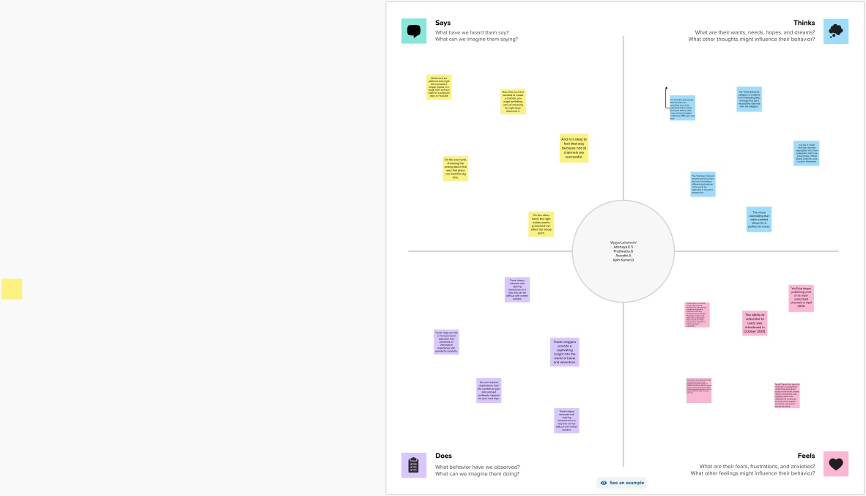

2.2BRAINSTROMING

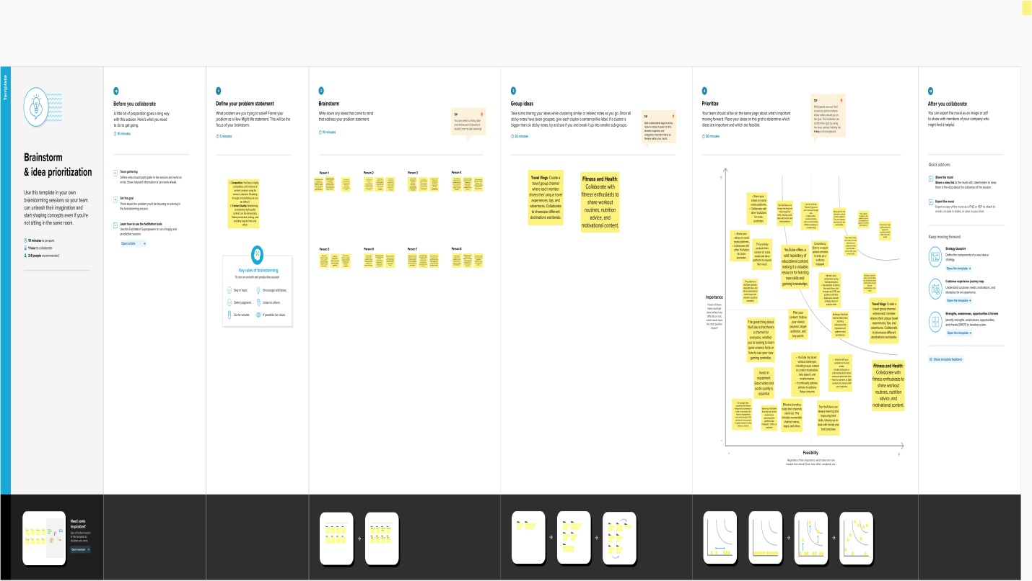

3.result:

We created the data visualization such as dash board and story using the data set provided.

Dash board 1

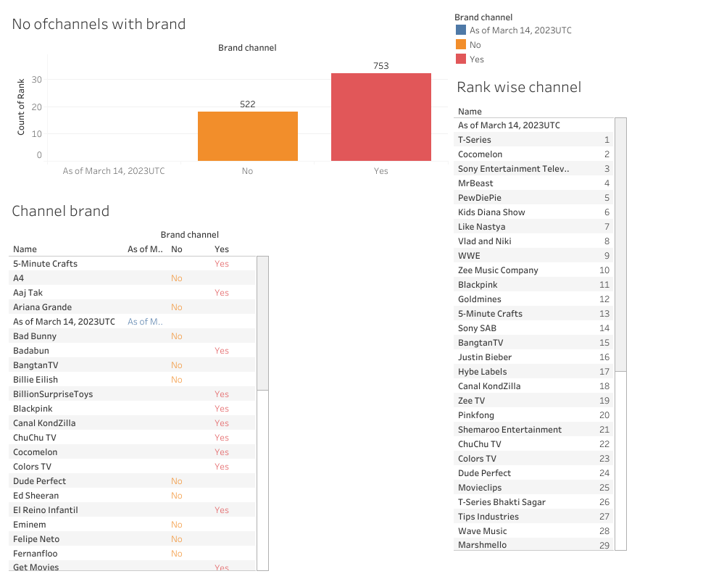

Dash board 2

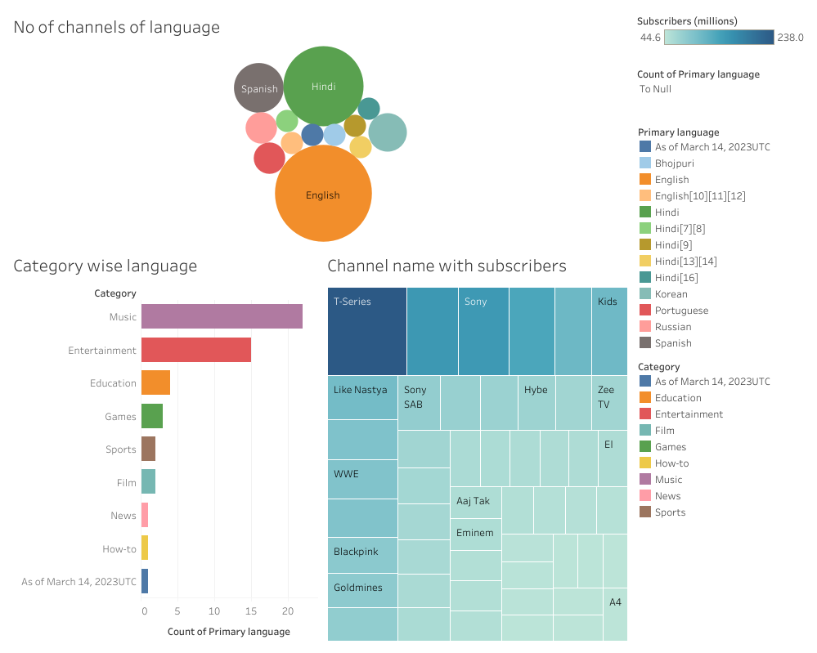

Dash board 3

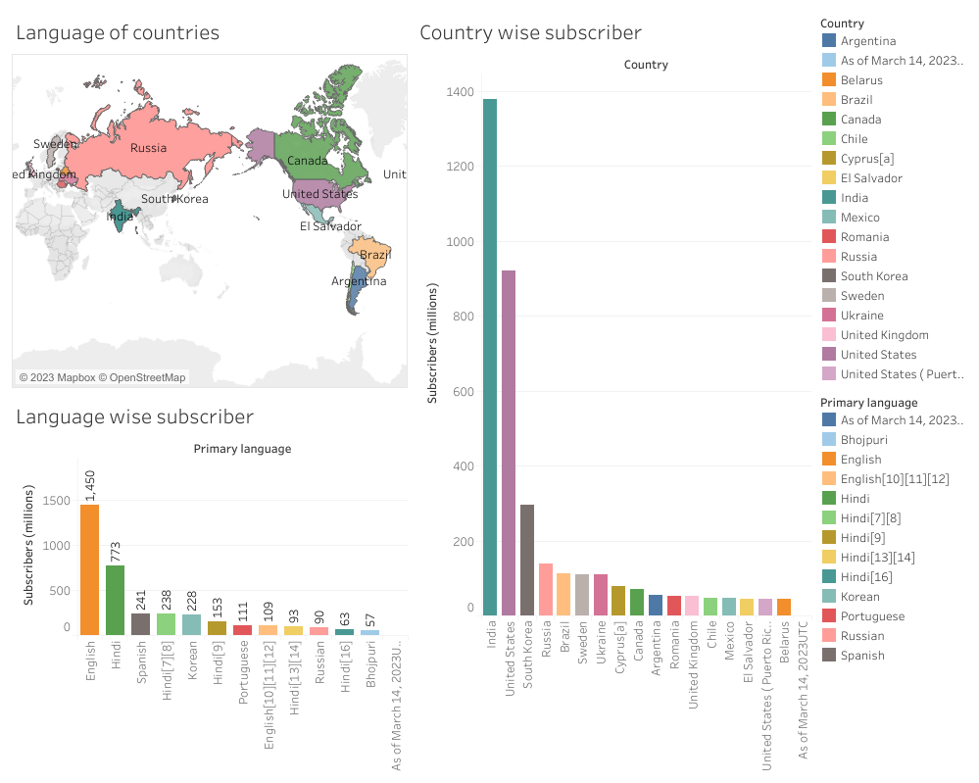

Story 1

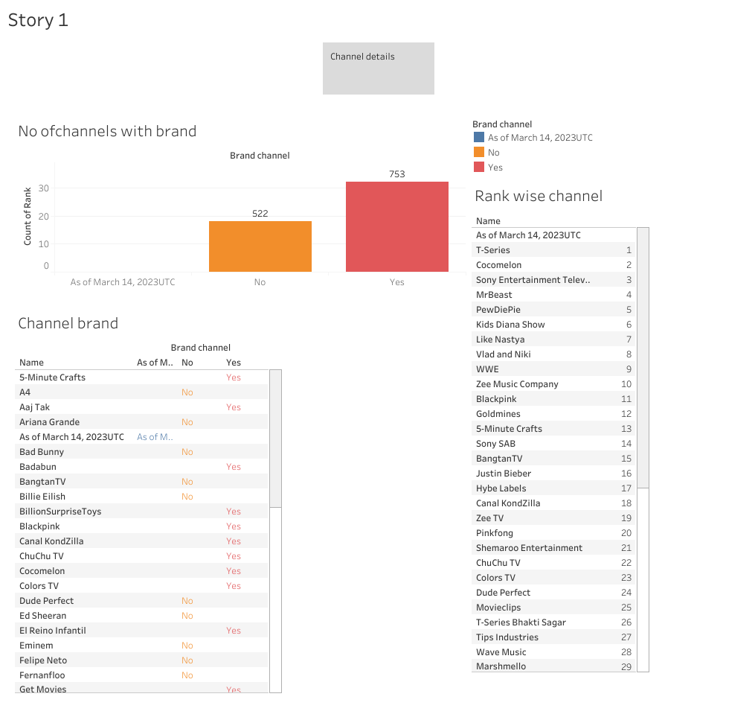

Story 2

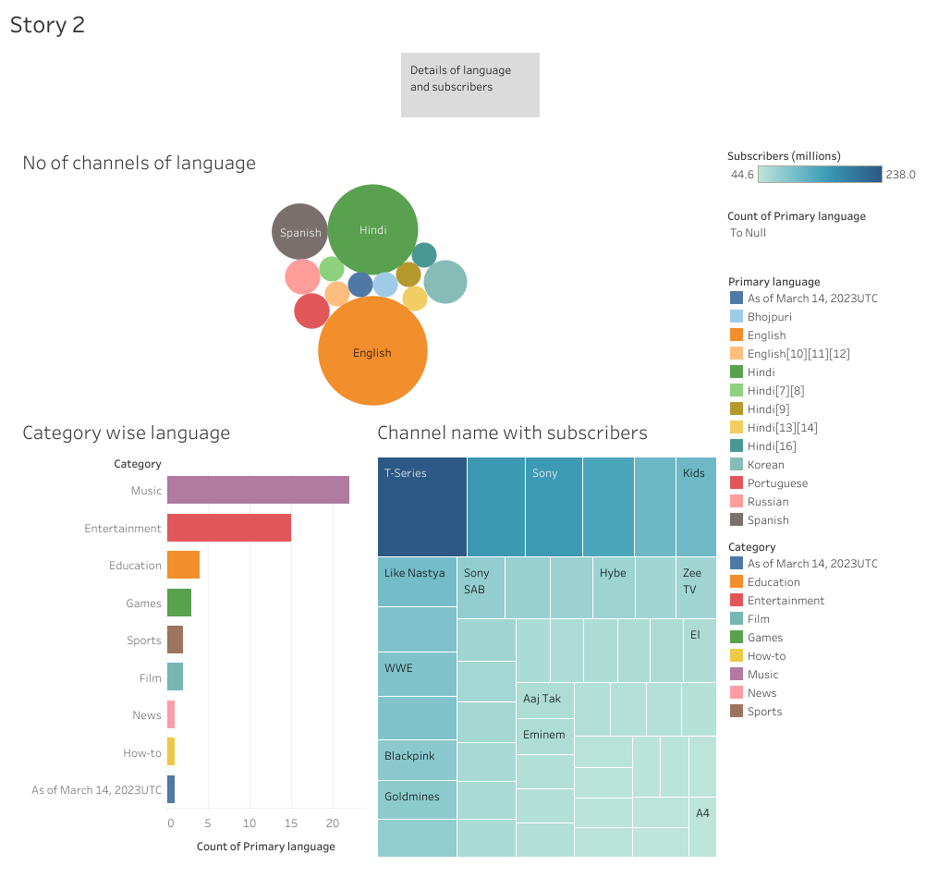

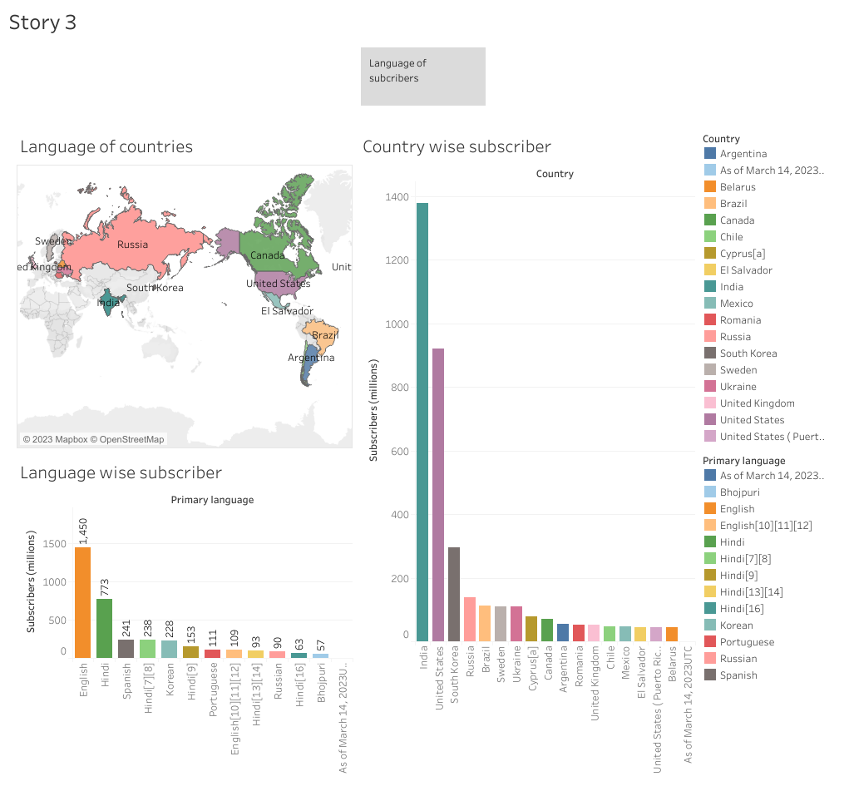

4.Advantages & disadvantages

Advantages

* YouTube is free, there are no fees to pay for using YouTube.
* So, You should not worry if you are starting out and experimenting with its use.
* You can practice and test your own creative ways of doing videos and see how the market reacts for free.
* Using YouTube to reach the media is cheap and easy.
* YouTube has a wide variety of videos & infomercials.
* Expressing your creativity through YouTube is a major benefit and you can get a

Disadvantages:-

* If you have made a popular channel, you need to edit your YouTube videos add some video
* The maintenance costs like the digital cameras, hiring skilled people, and investment for buying some costly instruments all require moneyence to it like annotation.
* YouTube is public, So, anyone can see the videos that you post, Anyone can post a video, there could be copyright infringement issues.
* If the children can access YouTube, you probably need a parental block, Some videos can sometimes be inappropriate without warning.

5.Application

In mid-2018, the subscriber count of the Indian music video channel T-Series rapidly approached that of Swedish web comedian and Let's Player PewDiePie, who was the most-subscribed user on YouTube at the time.[76][77] As a result, fans of PewDiePie and T-Series, other YouTubers, and celebrities showed their support for both channels. During the competition, both channels gained a large number of subscribers at a rapid rate, and surpassed each other's subscriber count on multiple occasions in February, March, and April 2019.[52][53][54][56] T-Series eventually permanently surpassed PewDiePie, and on May 29, 2019 it became the first channel to reach 100 million subscriber.

6.Conclusion

All 50 of the channels have surpassed 40 million subscribers, 39 of them have surpassed 50 million subscribers, 23 of them have surpassed 60 million subscribers, 16 of them have surpassed 70 million subscribers, 12 of them have surpassed 80 million subscribers, 10 of them have surpassed 90 million and 7 of them have surpassed 100 million subscribers. Only 1 channel (T-Series) has surpassed 200 million subscribers.

7.Future scope

* YouTube is constantly changing, and with those changes come new opportunities for content creators
* Here’s what you need to know about the future of the YouTube platform so that you can stay ahead of the curve.
* It’s no secret that YouTube is a powerful force in the online world. With over 1 billion users and counting, the video-sharing platform is a significant player in online advertising and content distribution.
* As a YouTube creator, it’s important to stay up-to-date on the latest changes and developments to the YouTube platform.
* We’ll discuss some of the significant changes coming to YouTube in 2022 and what you need to know about them. So whether you’re a veteran YouTuber or just starting, read on for the latest news and tips!
* Recent reports show that YouTube accounts for 44% of online video traffic.